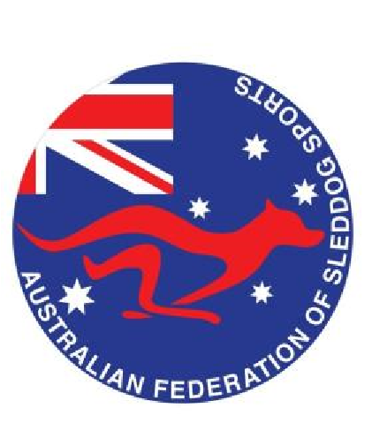
Australian Federation of Sleddog Sports
2026 Individual Membership Application
Membership is valid from 1st January 2026 – 31st December 2026.
 | Option 1: Single Membership | Option 2: Family Membership
Cost: | $25 | $35
Select
Primary Member:
Postal Address:
State:
Postcode:
Contact Number:
Email Address:
Signature: |  | Date:
Please Note: A family membership consists of 2 adults and children under the age of 18yrs. Only those over 18 years old have the right to vote on AFSS matters. This form is only valid once signed and dated by all applicants over 18 years old.
Additional Members:
Secondary Member:
Signature |  | Date:
Please list all children under 18 years:
Child 1: |  | Age:
Child 2: |  | Age:
Child 3: |  | Age:
Child 4: |  | Age:
Members and affiliated RGO’s are expected to adhere to the AFSS Code of Conduct, Sportsmanship Policy,
Social Media Policy, Aggressive Dog Policy and Race Rules.

Please return this form to:  AFSS Secretary:  Adelaide Reilly  Email:  afss.secretary@gmail.com |  | The AFSS review and approve all new requests for individual membership.  Once your membership has been approved by the committee the AFSS secretary will provide payment details by email.
Office Use Only
Secretary : | Treasurer: |  | Membership Number:

Membership Application Form – January 2026

