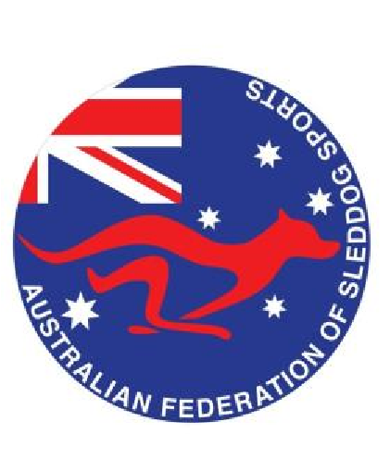
Australian Federation of Sleddog Sports
2026 Sleddog Club Affiliation Application
Please complete all sections.
Organisation Name:
Postal Address:
Primary Contact: Phone:
Email:
Nominated AFSS Council representative:

Affiliation Options (Please select one)
 | Option 1: Multiple Event RGO | Option 2: Unlimited Club Affiliation
Description | Affiliation for clubs with a member base consisting of a race organising Committee only. Includes insurance coverage for multiple RGO events and AFSS point score eligibility. | Affiliation for clubs with a member base consisting of an unlimited number of members. Includes insurance coverage for multiple RGO events and AFSS point score eligibility.
Cost  Memberships  Select | $230 | $540
Cost  Memberships  Select | RGO – Committee only | Unlimited memberships for all current financial members of affiliated RGO
Please attach a copy of your RGO calendar of registered events to this application and include advice
as to which event you wish to be submitted into the AFSS Point score.
Calendar of registered events attached

Please return this form to:  AFSS Secretary:  Adelaide Reilly  Email:  afss.secretary@gmail.com | EFT Details:  Account Name: AFSS  BSB: 633-000  Account: 159 176 338  Description: ‘Club Name’ Affiliation

Please note in affiliating to AFSS:
- Only events listed on this form will be covered under the AFSS group insurance policy. If you decide to hold any additional events, please advise AFSS.
- RGO’s may seek an amendment to AFSS race rules following an application to AFSS. Rule amendments will only be approved if they do not have negative health, safety or welfare issues for dogs, drivers or handlers.
- If you are conducting training or expo day please adhere to rules that cover temperature, disease, medication – drivers & dogs, equipment and abuse.
- All Members and affiliated RGO’s are expected to adhere to the AFSS Code of Conduct, Sportsmanship Policy, Social Media Policy, Aggressive Dog Policy and Race Rules.
- All Australian Tier-1 races will be included in the AFSS point score.

Sleddog Club Affiliation Form – January 2026

